EXPERIMENT: 7
DATE:16.07.26
Breadth-First Search (BFS)

Aim:

To write a Python program to implement the Breadth-First Search (BFS) algorithm for graph traversal.

Algorithm:

- Read the number of vertices and edges.
- Create the graph using an adjacency list.
- Read the starting vertex.
- Create an empty queue and a visited list.
- Insert the starting vertex into the queue and mark it as visited.
- Remove the front vertex from the queue.
- Display the current vertex.
- Add all unvisited adjacent vertices to the queue.
- Repeat Steps 6–8 until the queue becomes empty.
- Display the BFS traversal.

Program:

from collections import deque
graph = {}
n = int(input("Enter the number of vertices: "))
e = int(input("Enter the number of edges: "))
print("\nEnter the edges (source destination):")
for i in range(e):
u, v = input().split()
if u not in graph:
graph[u] = []
if v not in graph:
graph[v] = []
graph[u].append(v)
graph[v].append(u) # Remove this line for directed graph
start = input("\nEnter the starting vertex: ")
visited = set()
queue = deque()
visited.add(start)
queue.append(start)
print("\nBFS Traversal:")
while queue:
vertex = queue.popleft()
print(vertex, end=" ")
for neighbour in graph[vertex]:
if neighbour not in visited:
visited.add(neighbour)
queue.append(neighbour)

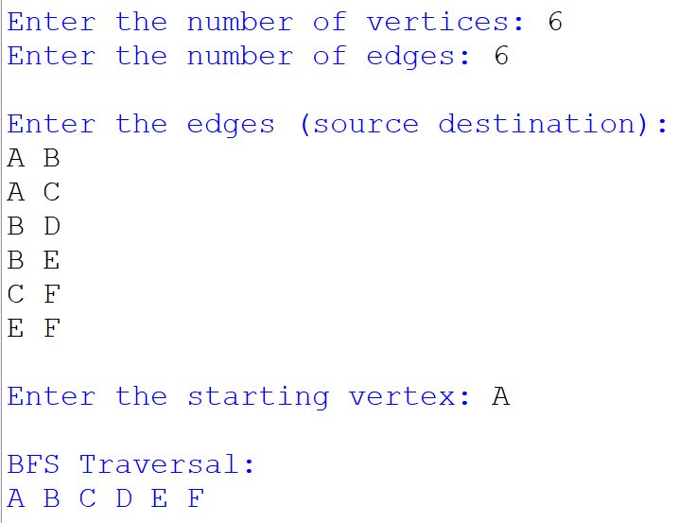
Output:

Result:

Thus, the Python program to implement the Breadth-First Search (BFS) algorithm was successfully executed, and the graph was traversed in Breadth-First Search order.

